Raymond You and Sarah Wessel

Lab 8

Assignment 1

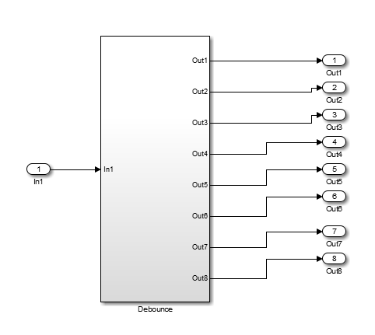

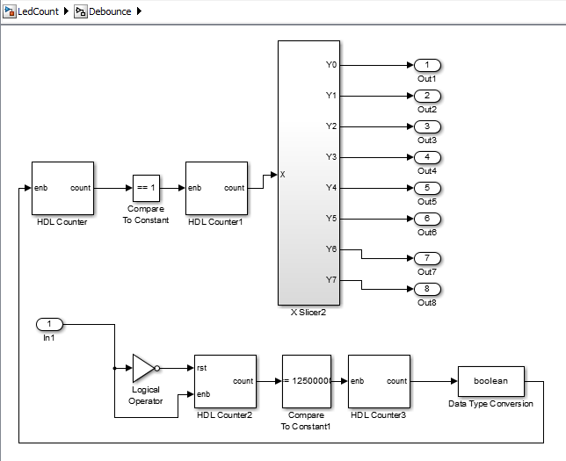

HDL Counter2 has an initial value of 0 and a step value of 1 with counter type free running. When the button is held down, the counter increments by 1 and when you let go, it resets back to 0.

HDL Counter3 has an initial value of 0 and a step value of 1. It outputs into a Boolean converter which switches its output from 1 to 0 after each count. The value of this counter will switch when the button is pressed.

HDL Counter has a step value of 1 and a count to value of 25000000 which feeds into a compare to constant block. While the HDL Coder is receiving a high value, the block should output 1 every second.

HDL Counter1 has an initial value of 0 and a step value of 1 and counts to value 255 because the maximum output is 8 bit.

Assignment 2

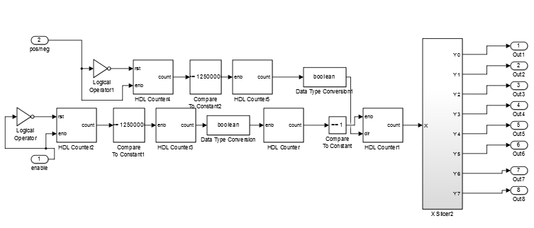

Counter Values in HDL Counter4 are the same as values in HDL Counter2. Values in HDL Counter5 are the same as values in HDL Counter3. All other counter values are the same as in Assignment 1.

Assignment 3

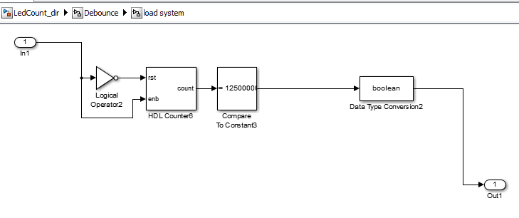

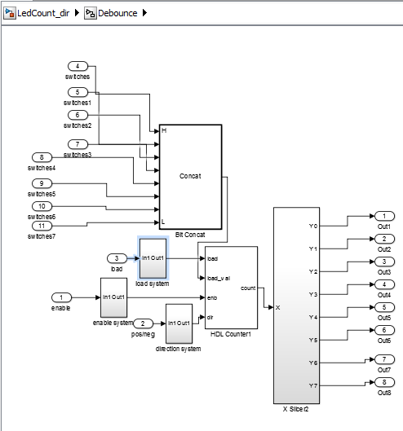

Counter values in load system are the same as in the other subsystems with the exception of the removal of the second counter. There is also 8 new input values for all the switches which goes into a bit concat which adds all the individual bits into an 8-bit number.

Assignment 4

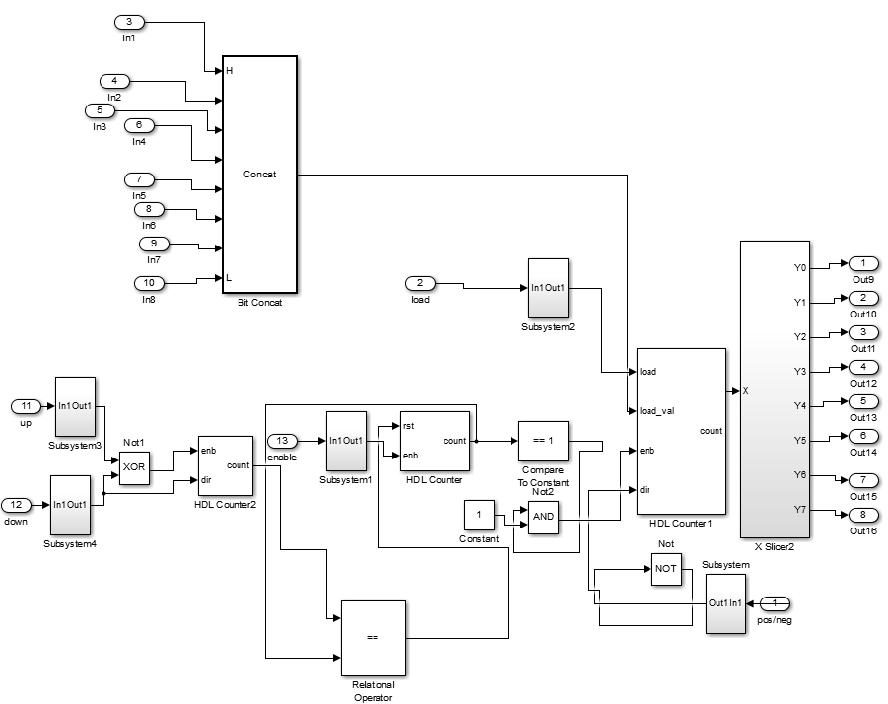

For HDL Counter, (which was free running) we set the initial value to 0 and the step value to 1.

For HDL Counter1, we set the initial value to 0, the step value to 1, and the count to value to 255.

For HDL Counter2, we set the initial value to 25,000,000, the step value to 5,000,000 and the counter value to 1,000,000,000.